<<20130901_rev-2>> Archived distributions can be retrieved at; <http://tinyurl.com/azg3eyl>. This archive includes a html version of this list distribution and its MS/WORD version with its filename as “year-month-date.doc.” You can also access all of its attachments, if any.
*******************************************************************
I made a serious error in my previous distribution of this msg;
John Eger’s Columbia University seminar has now been changed to November 13th (Wednesday).
Subsequently, our GKCN/GEWS/GUS mtg and videoconference with John Eger at the Stevens Institute of Technology is to be held on November 14th (Thursday).
I marked this change in red below.
*******************************************************************
*******************************************************************
I sincerely regret to distribute this msg repeatedly.
John Eger is a very busy person, hence he has to leave in the morning of November 14th (Thursday), so that he will not be able to participate in our events on that day at the Stevens Institute of Technology.
On the other hand, we recently received a msg from the NSF suggesting to apply for a new program. We will then proceed simultaneously all three cases of our GKCN/GEWS/GUS projects in Africa — see Sections 4, 5, and 6 in the Reference (g) below. Our videoconference on November 14th may then include some participants from Eastern Africa, too, compared with the one on last April 18 which was only for ECOWAS countries. Keep up with my future list distributions.
I marked this change in green below.
*******************************************************************
princess claudia windisch graetz <dashaeusle@t-online.de>
Mr. Jerry Spivack <JSPVK@AOL.COM>
John M. Eger <jeger@mail.sdsu.edu>
Prof. Victor B. Lawrence <Victor.Lawrence@stevens.edu>
Youcef Oubraham <Youcef.oubraham@stevens.edu>
Michael Scalero <mscalero@stevens.edu>
Maria Lourdes B. Toloza <mtoloza@stevens.edu>
References:
(a) (20130831) "Creativity" in John Eger's essay and Columbia University seminar on December 11 (Wednesday), 2013 — this to be changed to November 13th (Wednesday)
<http://tinyurl.com/mqxt5ly>
(b) (20130406) Tapio Varis' talk at the Columbia University seminar " Knowledge Technology, and Social Systems" in the evening of April 17th and GEWS/GUS conference at Stevens Institute of Technology on April 18th
(c) (20130410) Procedures how to access webinar videoconferencing during Public Video-Conference on West African Broadband Internet Initiatives at Stevens Institute of Technology on April 18, 2013
<http://tinyurl.com/kwb48sy>
(d) (20130416) REMINDER ON “Public Seminar on African Broadband Internet and Early Warning System Launch,” which is to be held at the Stevens Institute of Technology on April 18th
<http://tinyurl.com/d82y25g>
(e) (20130422) Report on “Public Seminar on African Broadband Internet and Early Warning System Launch” held at the Stevens Institute of Technology on April 18, 2013
<http://tinyurl.com/berm8k9>
(f) 20130425) Recording of GLH/ECOWAS videoconferencing at the Stevens Institute of Technology on April 18th
<http://tinyurl.com/cmeohg6>
(g) Utsumi, T., “The Global Knowledge Center Network (GKCN) with The Global University System (GUS)” (June 25, 2013)
<http://tinyurl.com/o5l22ll>
I. John Eger’s seminar at Columbia University in the evening of December 11, 2013 -- this to be changed to November 13th (Wednesday) :
Dear Princess Claudia in Germany and E-Colleagues in NYC area:
(1) Pls feel free to attend John Eger’s seminar on December 11th (this to be changed to November 13th (Wednesday)) (Reference (a) above), as my guest.
(2) The seminar starts from 7:00 pm to last till 9:00 pm.
(3) Should you wish to have a dinner from 6:00 pm together with us, pls reserve a seat with Jerry Spivack — it usually costs US$25.00 which is to be paid to Jerry with your check addressing to Columbia University — no cash accepted.
Dear Princess Claudia in Germany:
I believe that you are familiar with those procedures, since you attended Tapio’s seminar (Reference (b) above).
Many thanks for your msg (ATTACHMENT I below). I am taking the liberty of uploading a few photos you recently sent to me — I am awfully regret I could not attend a wonderful opera event with prominent performers from around the world at your castle with beautiful gardens;
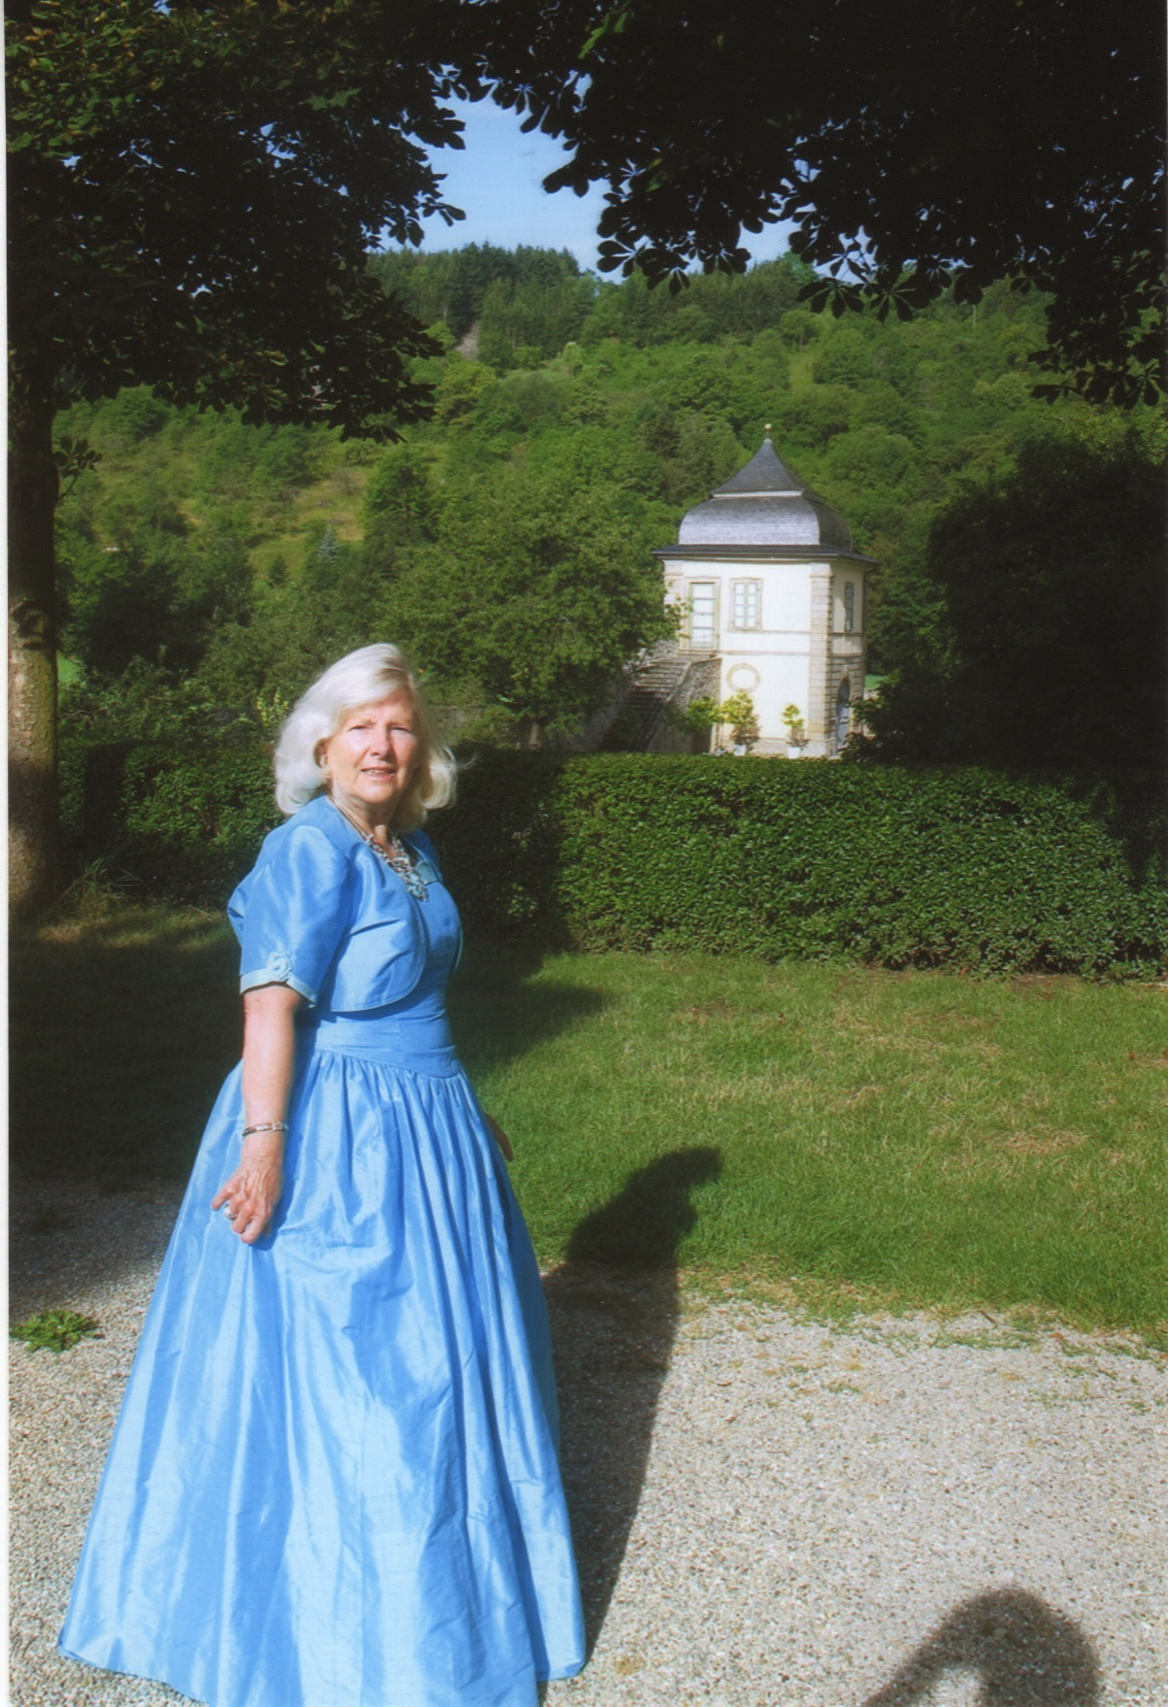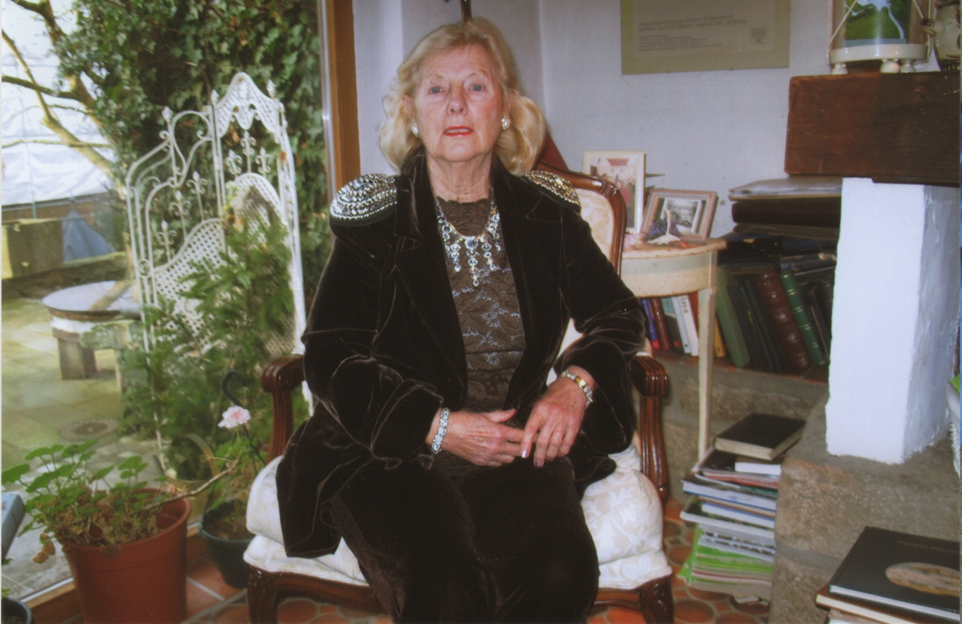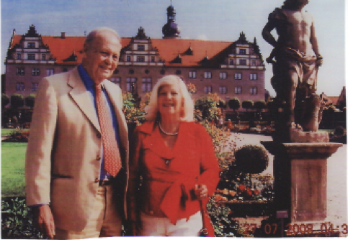
II. Possible GKCN/GEWS/GUS mtg and Videoconferencing around Africa from Stevens Institute of Technology on December 12, 2013 -- this to be changed to November 14th (Thursday):
(4) Although not confirmed yet, we plan to have a similar discussion mtg of our GKCN/GEWS/GUS projects (Reference (g) above) and a videoconference (from 9:00 am to 12:30 pm) on December 12th (Thursday) this to be changed to November 14th (Thursday), 2013 originating at the Stevens Institute of Technology in Hoboken, NJ, as we had with you and Tapio on April 18th, 2013 (References (c) to (f) above).
Dear Victor, Maria, Mike and Youcef:
Pls kindly reserve the conference room and Blackboard Collaborator on December 12th (Thursday) this to be changed to November 14th (Thursday).
See you there, and keep in touch.
Best, Tak

ATTACHMENT I
From: <dashaeusle@t-online.de>
Subject: Re: [gu-new] (20130831) "Creativity" in John Eger's essay and Columbia University seminar on December 11 (Wednesday), 2013
Date: September 1, 2013 5:04:56 AM EDT
To: <takutsumi0@gmail.com>
Reply-To: <dashaeusle@t-online.de>
dear prof. dr. taki utsumi,
i would like to thank you for your reply to my last email
and request that you would please send me an invitation
on december 11,2013 to your seminar at colombia university
you should have a responsible colleague among your contacts
for every nation in the global community to contact the universities
in each country and their responsible dean of each international communications
policy action teaching, so that the university students get direct contact with the
movers and shakers that have like you in the lead, pioneered this effort since 40
years so as to iniate tese students directly to get in the knowledge community.
please advise.
have a nice sunday in new york city.
thanky you
princess claudia windisch graetz

List of Distribution
prince gottfried and princess claudia windisch graetz
exec. producer,writer and directors of:
GLOBAL SATELLITE BROADCASTING FOR CULTURE;EDUCATION AND SCIENCE
INTERNATIONAL COMMUNICATIONS NETWORK
ECOLOGY AND ELECTRONIC ENVIRONMENT CORP
tele: OO49-07934-993724
das haeusle
am graben 6
97990 weikersheim
baden wurtemburg Germany
dashaeusle@t-online.de
Mr. Jerry Spivack
Co-Coordinators
Knowledge, Technology, and Social Systems seminar
Columbia University
or
President
Inter/Action
11 Wavery Place
New York, NY 10003
917 721 0252
JSPVK@AOL.COM
John M. Eger
Lionel Van Deerlin Endowed Chair of Communication and Public Policy
School of Journalism and Media Studies
Director, The Creative Economy Initiative
San Diego State University
5500 Campanile Drive
PFSA 361E
San Diego, CA
92182-4522
tel: 6195946910
jeger@mail.sdsu.edu
http://www.smartcommunities.org/
http://www.smartcommunities.org/guidebook.html
http://www.iicom.org/intermedia/july2001/eger.htm -- His paper on Smart Communities in InterMedia.
Prof. Victor B. Lawrence
Associate Dean: Special Topics
Batchelor Chair Professor of Electrical Engineering
Department of Electrical & Computer Engineering
Burchard Building, Room 205
Stevens Institute of Technology
Castle Point on Hudson
Hoboken, NJ 07030
Ph.: 201 216-5636
Cel: 732-407-9500
Fax.: 201 216-8246
Victor.Lawrence@stevens.edu
http://www.ece.stevens-tech.edu/iNetS/people/LawrenceVita.html -- brief bio
http://www.stevens.edu
Youcef Oubraham
E-Learning Technologies Administrator
Library Systems Administrator
Information Technology
Stevens Institute of Technology
Castle Point on Hudson
Hoboken, NJ 07030
Phone: 201-216-5418
Youcef.oubraham@stevens.edu
Michael Scalero
E-Learning Technology Manager
Information Technology
Stevens Institute of Technology
The Innovation University
Castle Point on Hudson
Hoboken, NJ 07030
201-216-5475
Cel: 201-805-7551
Fax: 201-216-8960
mscalero@stevens.edu
www.twitter.com/mscalero
www.stevens.edu
Maria Lourdes B. Toloza
Department of Electrical & Computer
Engineering (Burchard Building)
STEVENS INSTITUTE OF TECHNOLOGY
Castle Point on Hudson
Hoboken, NJ 07030
201-216-5623 (v) 201-216-8246 (f)
mtoloza@stevens.edu
or
Electrical and Computer Engineering Department
Stevens Institute of Technology
Burchard 212
Hoboken, NJ 07030

*******************************************************************************
Takeshi Utsumi, Ph.D., P.E., Chairman
GLObal Systems Analysis and Simulation Association in the U.S.A. (GLOSAS/USA)
Laureate of Lord Perry Award for Excellence in Distance Education
Founder and V.P. for Technology and Coordination of Global University System (GUS)
43-23 Colden Street, #9L, Flushing, NY 11355-5913, U.S.A.
Tel: 718-939-0928; Cel: 646-589-1730; Skype: utsumi
Email: takutsumi0@gmail.com, Web: http://www.friends-partners.org/GLOSAS/
U.S./IRS Employer ID: 11-2999676 <http://tinyurl.com/534gxc>
New York State Tax Exempt ID: 217837 <http://tinyurl.com/47wqbo>
Google Profiles <https://profiles.google.com/takutsumi0/about>
Wikipedia <http://en.wikipedia.org/wiki/Takeshi_Utsumi>
Facebook <http://www.facebook.com/GlobalEarlyWarningSystemsgews>
List Distribution <http://tinyurl.com/2fzx23e>
*******************************************************************************

